Homework 2

David Adamashvili  
dadamashvili3@gatech.edu

***Abstract—*** In this paper I will be discussing on how an intelligent agent might categorize sandwiches. In the second part of the paper, I will creating abstract frames for four different types of jokes.

# Sandwiches

Let us think about what makes a sandwich a sandwich. I will list which foods, in my opinion, are sandwiches and which are not. I have not had the vast majority of these dishes, so pardon my ignorance if I mislabel any of them.

**Sandwich:** Ham and Swiss on a potato roll; meatball sub; Monte Cristo; grilled cheese sandwich; Neopolitan ice cream sandwich; veggie panini; bacon, egg and cheese biscuit; egg in a basket; French dip;

**Not a sandwich:** Hamburger; shawarma; chicken quesadilla; avocado toast; Klondike bar; sushi roll, French toast; sloppy joe; Mexican pizza; pigs in a blanket; Pop-Tart; Oreo cookie; buttered English Muffin; corn dog

## Incremental Concept Learning (ICL)

I will demonstrate ICL on two positive and two negative examples. These will be: grilled cheese sandwich, veggie panini, avocado toast and Oreo cookie (in this order). As we see on figures 1 and 2, the model changes after the first iteration (**generalizing to abstract features heuristic**), but in the following iterations nothing changes as those two sandwiches do not fit the model and are not sandwiches.

We should note that if we chose other sandwiches for ICL, or even the same sandwiches in a different order, we would get a different model as a result. For example, using an ice-cream sandwich would have added the possibility of having ice-cream as a filling in the result.

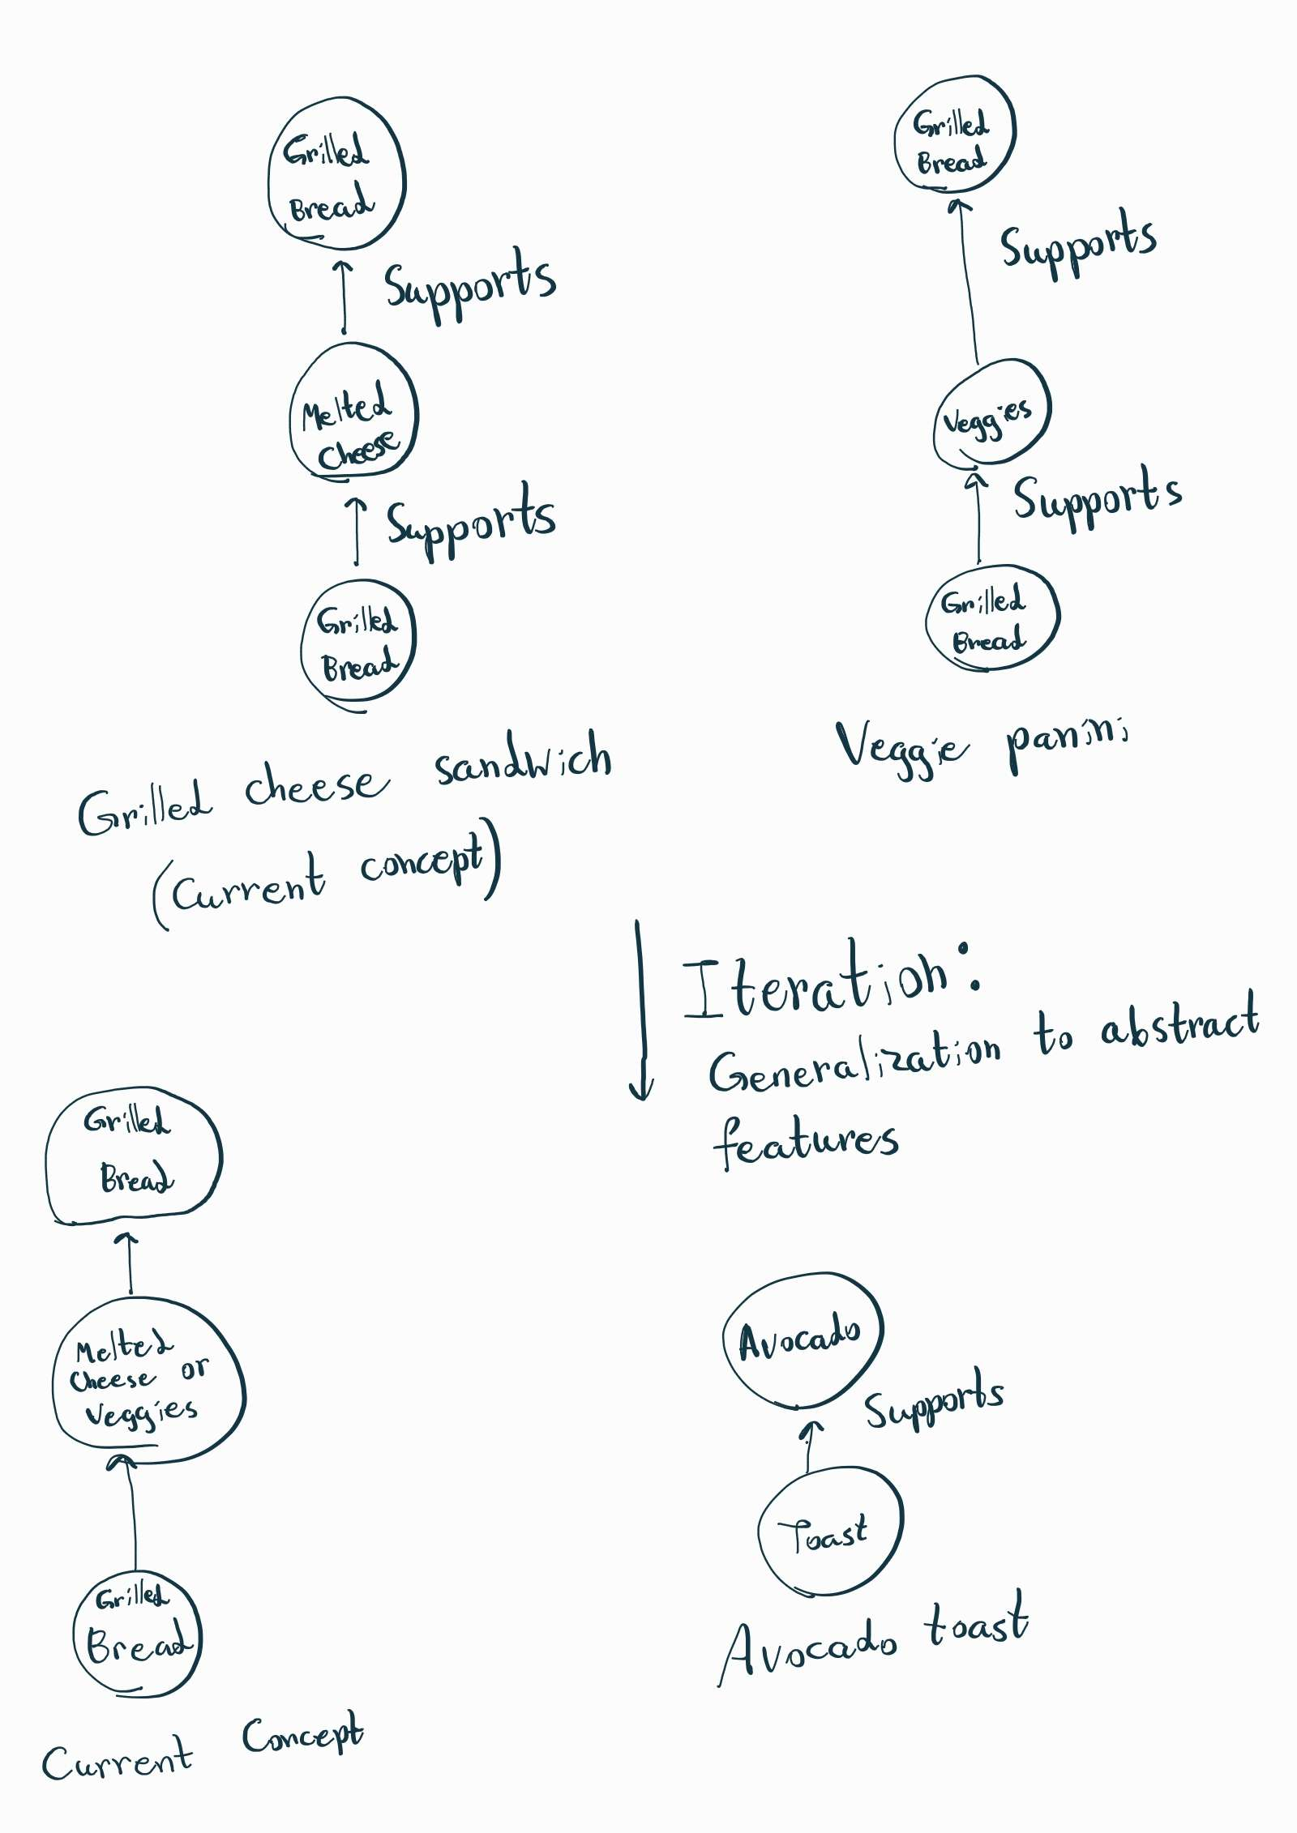

Figure - **Incremental Concept Learning (1 iteration)**

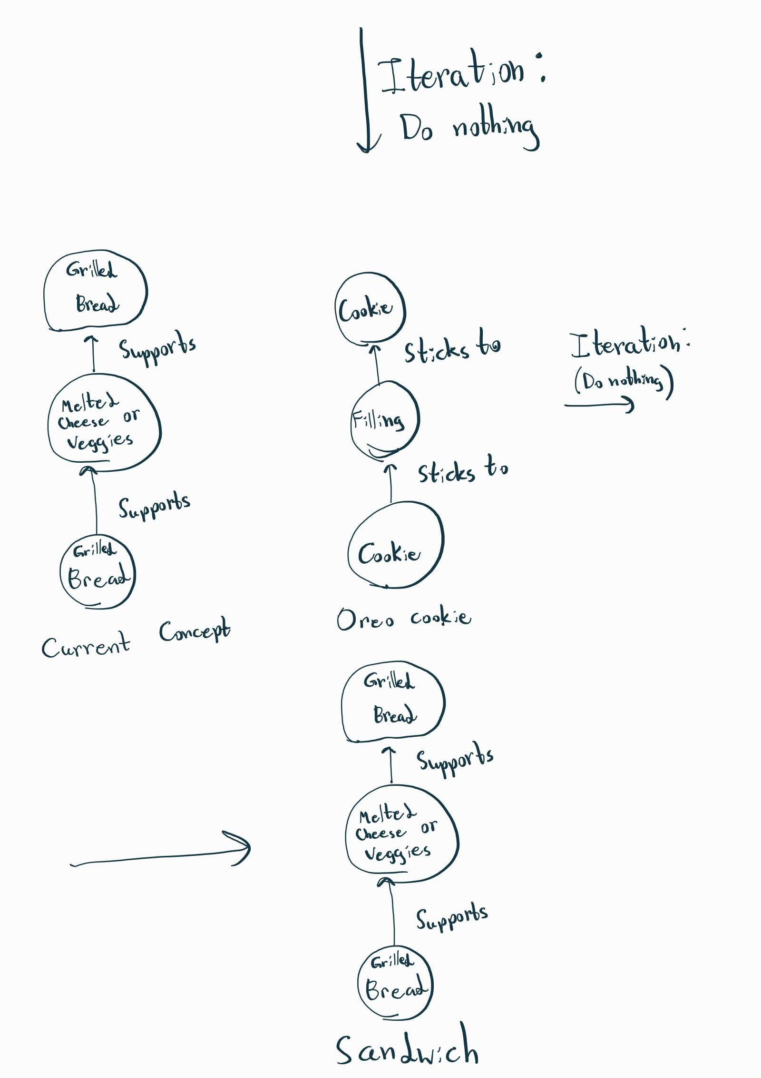

Figure - **Incremental Concept Learning (iteration 2 and 3)**

## Classification

For classification, I will be using the following **parameters**:

* Is the sandwich between two slices of bread?
* Does it have cheese?
* Does it have meat?
* Does it have condiments?
* Is it served hot?
* Is it savory?

Unfortunately, these parameters do not give a conclusive definition of a sandwich. Since none of the rows are all "Yes” or “No”, there is no concrete way to say if something is a sandwich or not.

Figure 3 – **Parameter definitions for 6 sandwiches**

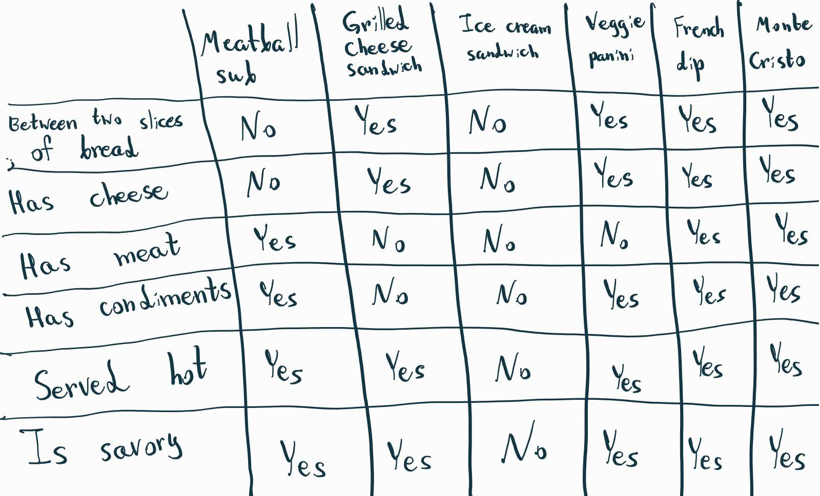

So the final **classification model** will be as follows:

* Between two slices of bread - Maybe
* Has cheese - Maybe
* Has meat - Maybe
* Has condiments - Maybe
* Is served hot - Maybe
* Is savory - Maybe

## Answers (Is hot dog a sandwich?)

**Incremental Concept Learning:** According to my ICL model, a hot dog is not a sandwich, as it does not consist of melted cheese or veggies between grilled bread loaves.

**Classification:** According to the classification model, there is no conclusive answer. A hot dog is either a sandwich, or it is not. If anything, this shows that whether something is a sandwich or not is very subjective, and coming up with a concrete definition is extremely difficult.

**Case Based Reasoning:** As for case-based reasoning, a meatball sub is very similar to a hot dog. I would say that the biggest difference is the shape of the meat inside. Because of this, I would say that a hot dog could be considered a sandwich, as the difference between the two is minimal.

It’s interesting that all three approaches returned completely different results!

# https://cdn.discordapp.com/attachments/529663506342084636/1080859989897388132/Notes_230302_183136.jpgJoke frames

Figure - **Joke type 1**

I will now consider four types of jokes, ranging from simple to advanced and create frames for describing their structure.

## Joke type 1 (4 year old)

These types of jokes are usually told by young children, who do not understand the intricacies of humor, but know that structurally it needs to consist of a question and a response. Typically, these two have no relevance to each other and semantically don’t make sense. Because of this, the frame will consist of a Question and an Answer slot with no default values (no stereotypes), as all other parts of the joke can vary. Example: **What did Bob say to the wall? Microwave!**

## Joke type 2 (8 year old)

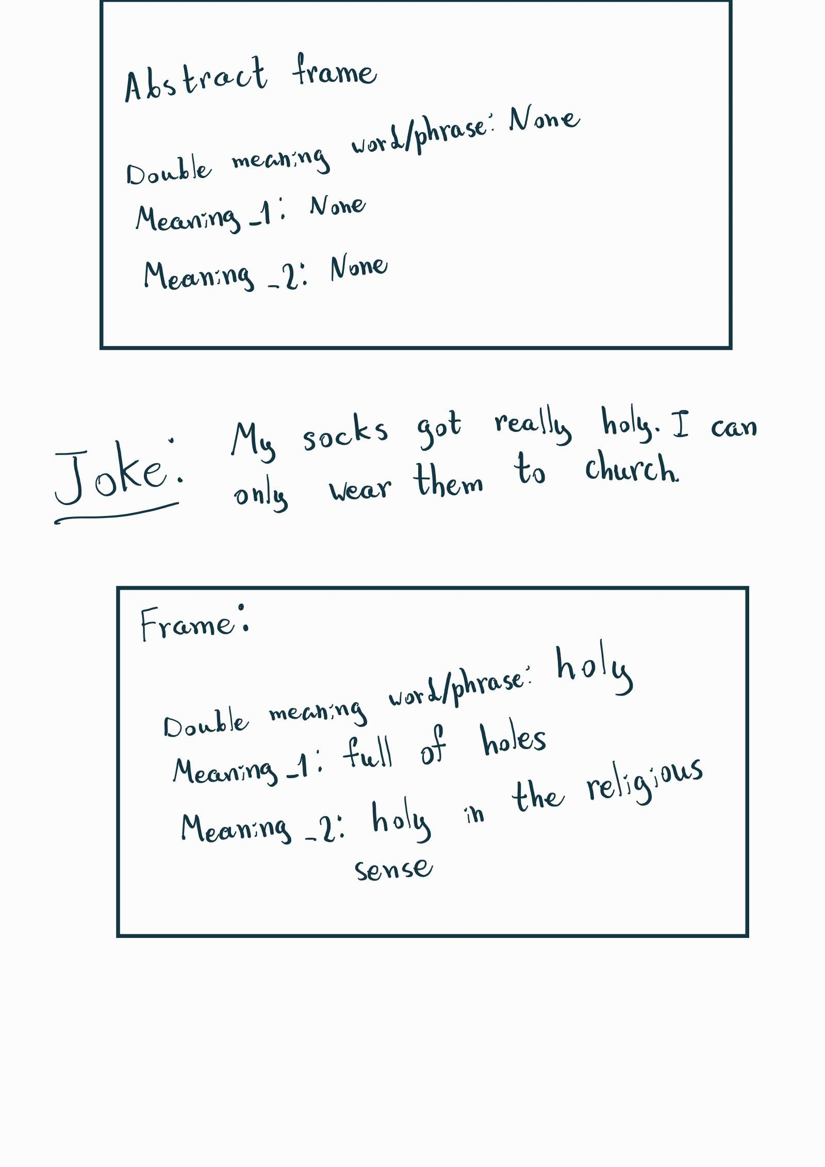When kids grow older, they start playing with double-meanings. They include a word or a phrase that could be understood in a few different ways. Otherwise, the joke can take different forms, so the frame would include both meanings of the word/phrase. Example: **My socks got really holy. I can only wear them to church.**

Figure - **Joke type 2**

## Joke type 3 (Anti-joke)

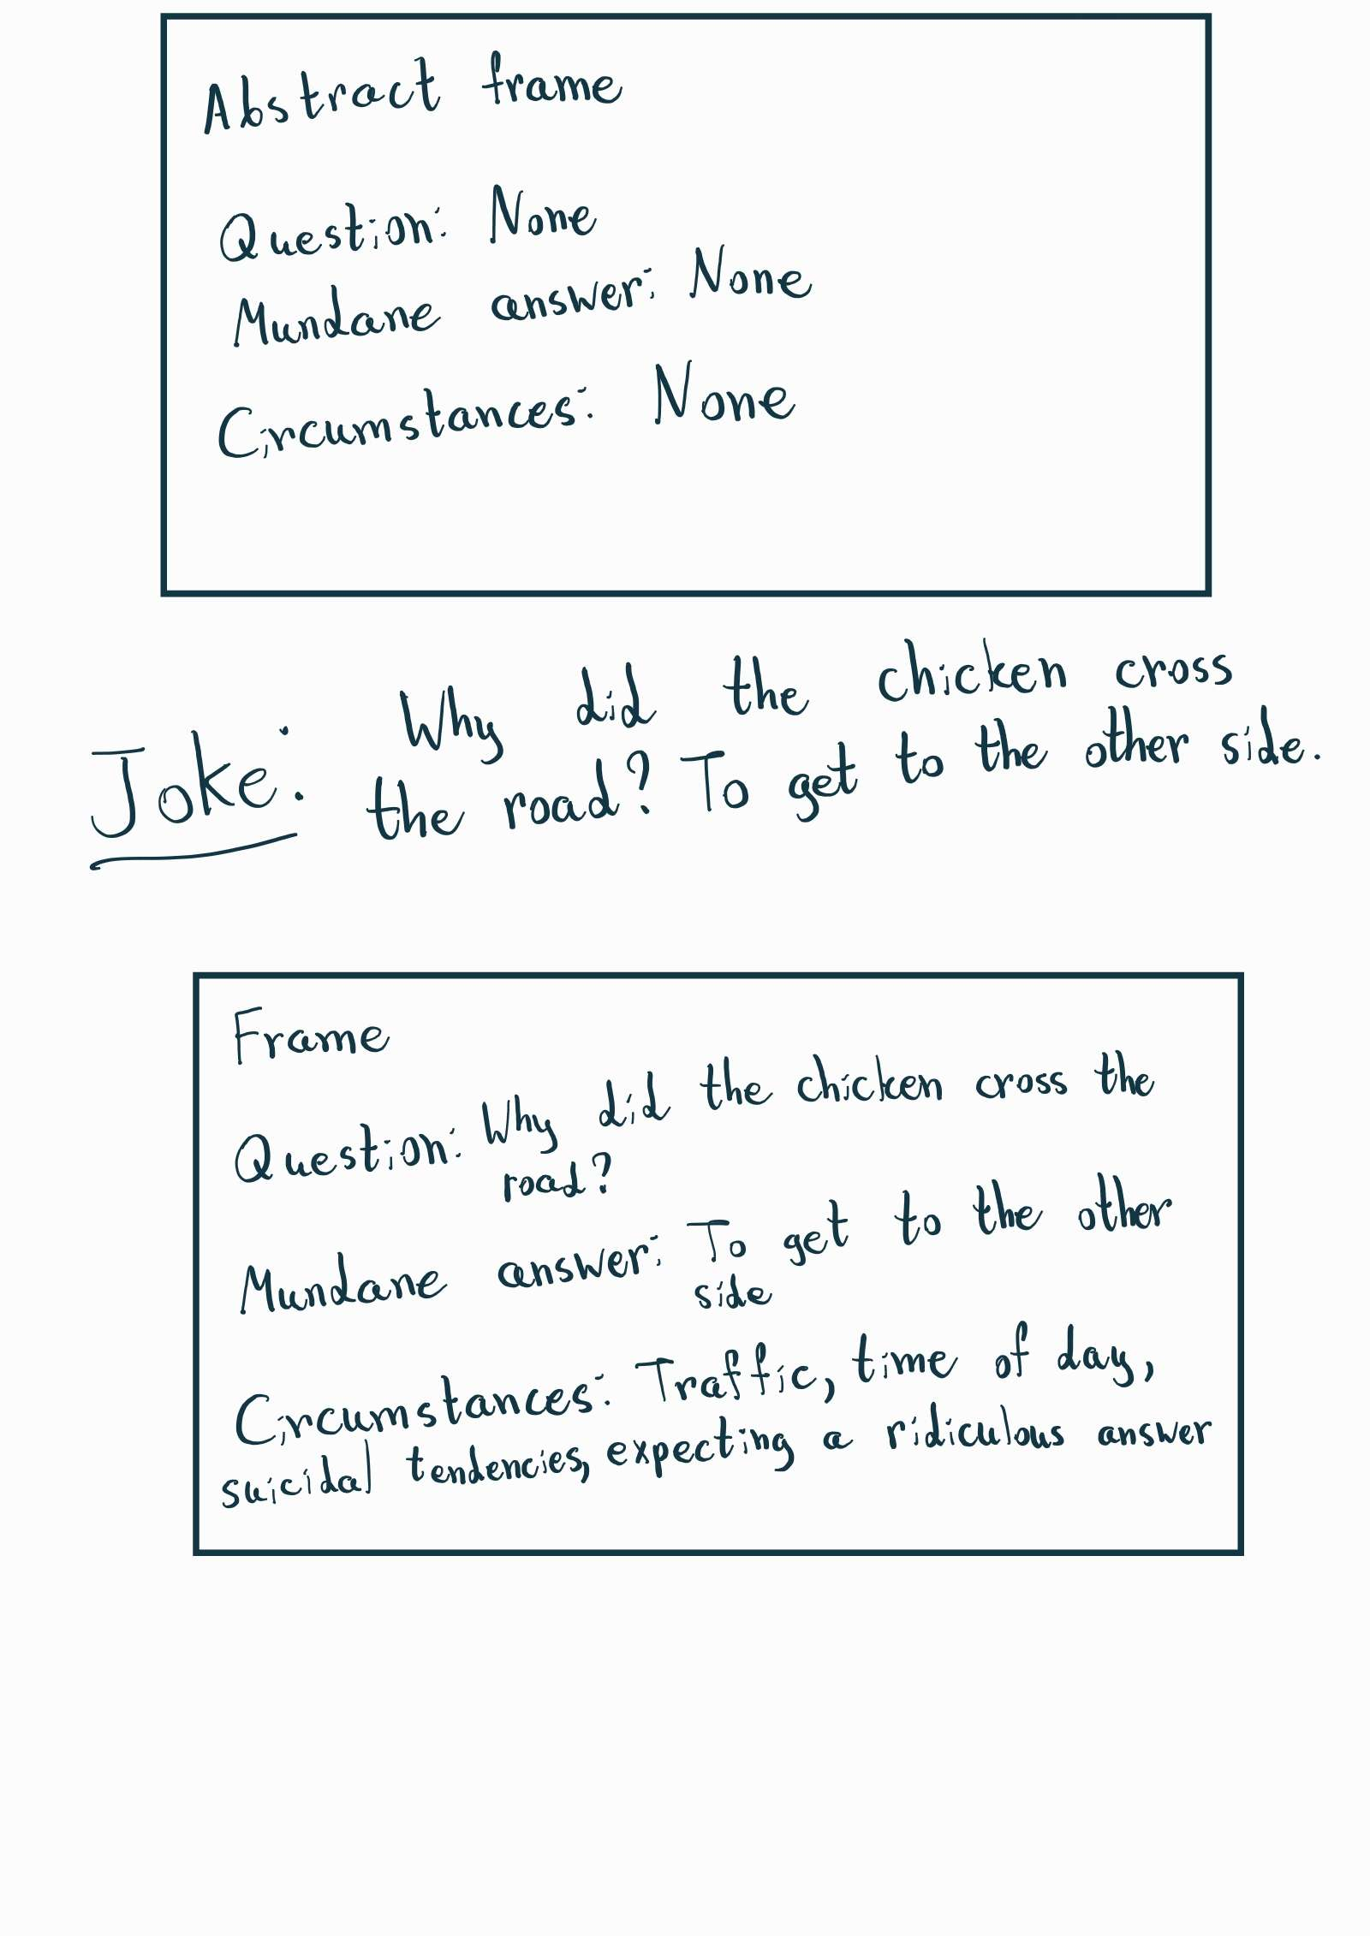This is a classic joke where the punchline is the most mundane answer one can think of. A great example of this is the classic “**Why did the chicken cross the road? To get to the other side**”. The crux of the joke is that people have prior expectations, and the simple answer catches them off guard. Because of this, there needs to be a slot for what the possible circumstances could be that would affect the punchline. For example, are there cars on the road? Maybe the duck is suicidal.

Figure - **Joke type 3**

## Joke type 4 (Chuck Norris fact)

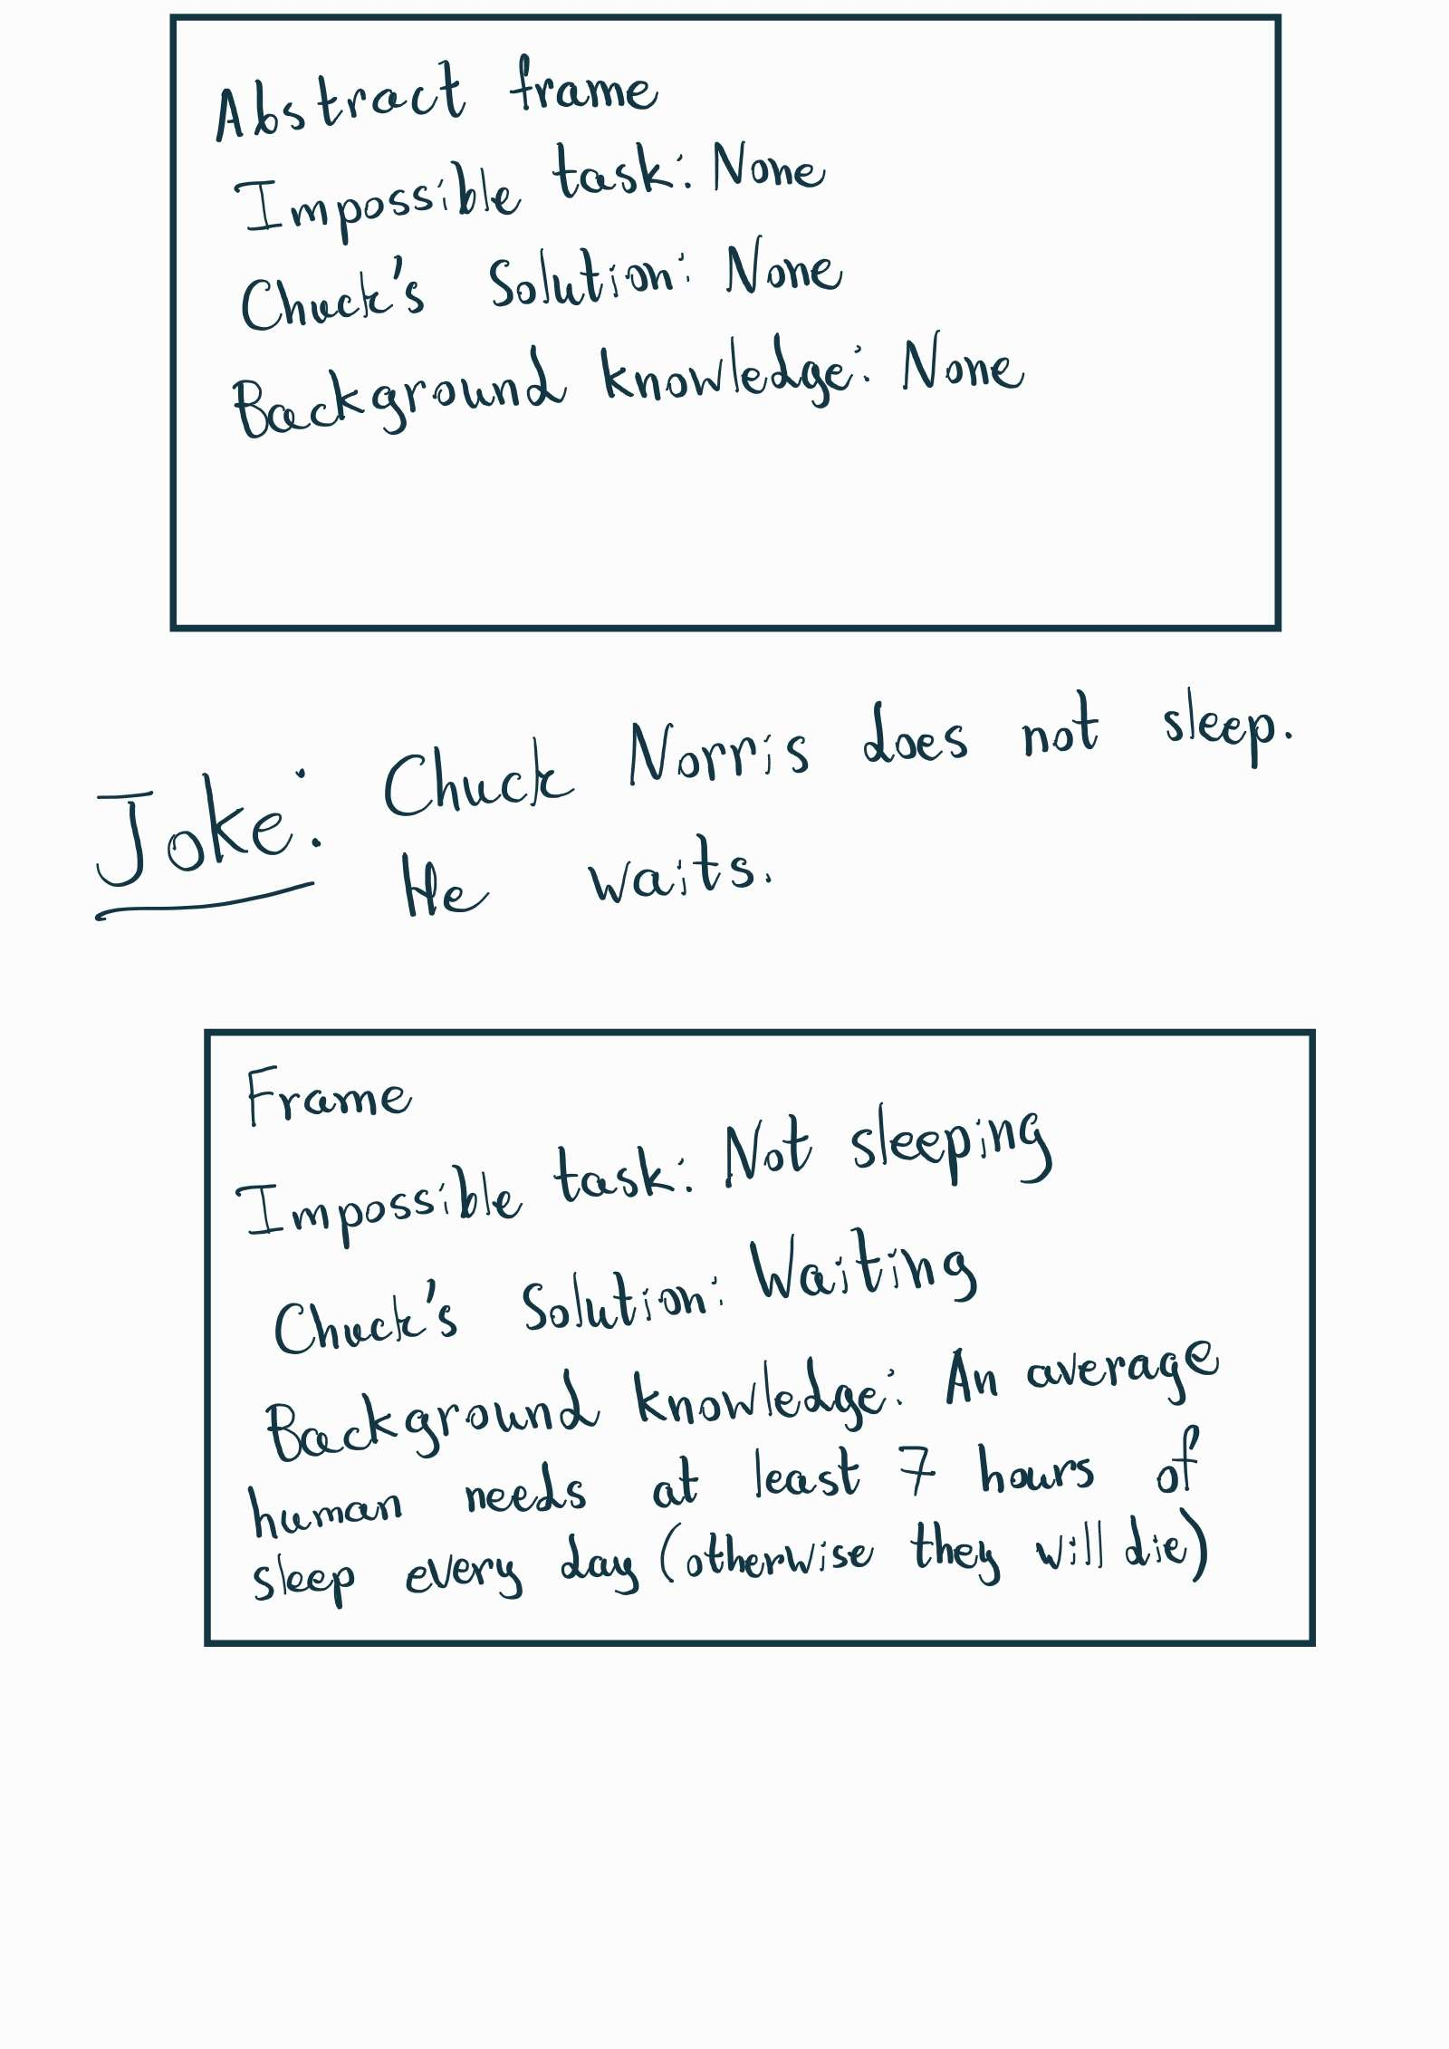These types of jokes involve the perfect human specimen, the man whose fists are registered as lethal weapons, the one and only Chuck Norris. They typically consist of an impossible task that Chuck manages to accomplish with ease. The frame will consist of an impossible task, and background knowledge on why the task is impossible, and the ridiculous way that Chuck accomplishes it. Note that, when I put the default value of “None” for the impossible task in the abstract frame, it is not because it’s empty, but because there is nothing Chuck can’t do. Example: Chuck Norris doesn’t sleep. He waits.

Figure - **Joke type 4**